Requesting Tests via Integrated ICE

**Roles who have ‘view only’ permissions**

Please access ICE via Investigations and then patient report list. You can then access services at the top left and anything that is available for you to access. See trouble shooting 1 ‘editing’ for further information. DO NOT ACCESS VIA TEST REQUEST ROUTE.

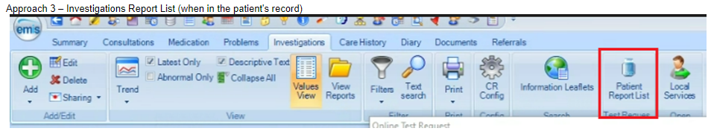

**Roles who have requesting rights**

1. Open a consultation, go to test request and online request

1. Choose the trust you would like to request the test with.

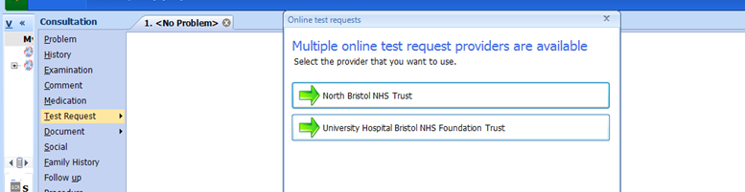

1. Search for tests which are to be requested and once selected press ‘continue with request’.

* + - NBT Default Requesting Screen:

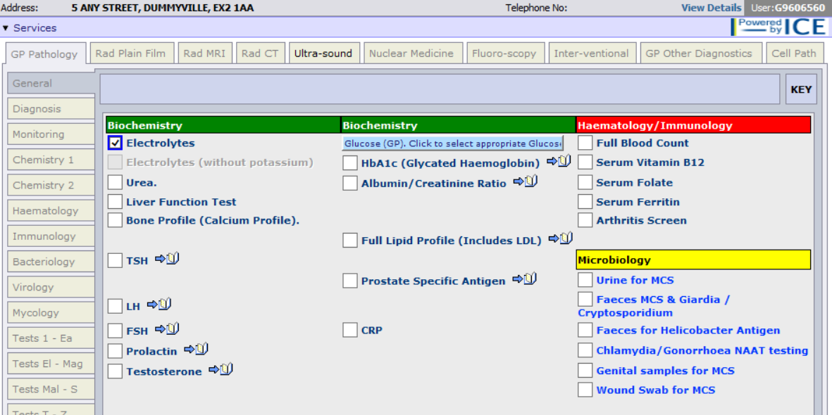

* + - UHB Default Requesting Screen:

1. Choose clinician from drop down and add clinically relevant information to the ‘other clinical details’ section.

1. UHB and NBT ICE order screens are slightly different when selecting if this request is for a delayed sample or not.
2. For a sample being taken when the test is requested:
   * + - UHB – Select ‘Now’, see below screenshot:

* + - * NBT – Select ‘Collect now’, see below screenshot:

1. For a delayed sample request:
   * + - UHB – Select ‘I want to fill out specimen details later’, see screenshot below:

* + - * NBT – Select ‘Community Phlebotomy’ and the collect now option will disappear, see screenshot below:

1. Once completed, press ‘accept request’.

Troubleshooting

1. Editing requests:
2. Go to investigations and ‘patient report list’.

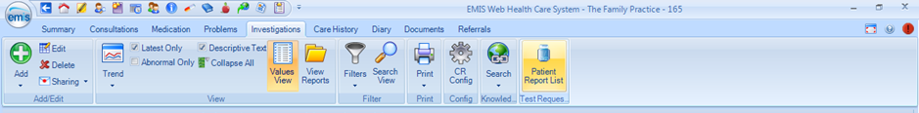

1. Top lefthand corner: find ‘services’ and drop down to patient request list’

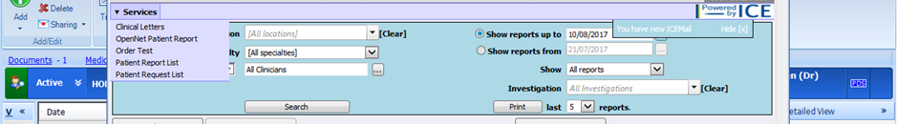

1. Press edit request and it will open you back up to step 3 as above.

1. If you forget to press the button stating ‘I wish to sample specimen later’ you will print off the ICE request forms used when taking bloods etc.

Version history

| **Version** | **Date** | **Author** | **Notes** |
| --- | --- | --- | --- |
| 0.1 | 03/08/2023 | Hannah Jones |  |
| 0.2 | 12/06/2024 | Aaron Halik, Hannah Jones | Updates |
| 0.3 | 09/10/2024 | Kerri Magnus (BNSSG TH/ALMC), Aaron Halik, Hannah Jones | Updates |