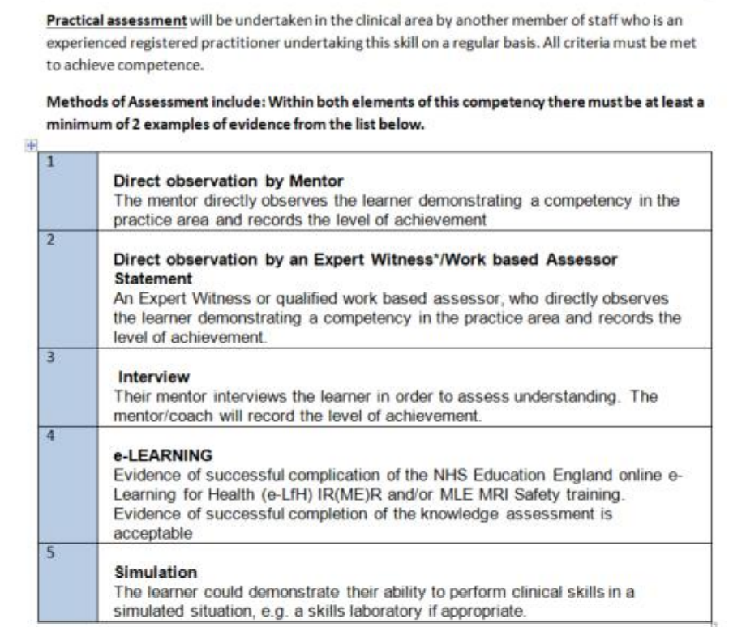
Imaging Competency Assessment Form for Named Nurses, Paramedics, Pharmacists, Physiotherapists and Podiatrists employed by General Practice or PCNs within the BNSSG area

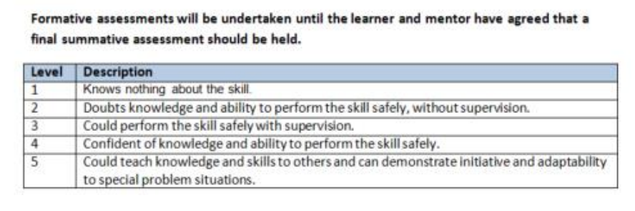
Imaging Competency Assessment Form for Named Nurses, Paramedics, Pharmacists, Physiotherapists and Podiatrists employed by General Practice or PCNs within the BNSSG area

I confirm that I am aware of my responsibilities, accountability and limitations in relation to practice relating to the Nurses, Paramedics, Pharmacists, Physiotherapists or Podiatrists Imaging procedures and role.

Candidates Name: |  | Date of birth:
Designation: |  | Practice/PCN
Candidate Signature: |  | Date Scope of Practice Signed:
Date Competency Completed: |  | Date Training Completed:

Assessor Name:
Designation:
Assessor Signature:

Keep original in your professional portfolio.

Remember
A competency level 4 (or above) must be demonstrated to provide assurance of knowledge and skills required to be perceived as being safe to continue without further education or assessment.
Reassessment of this competency must be undertaken at 3 years to comply with Ionising Radiation (Medical Exposures) Regulations (IRMER) 2017.
This assessment must be kept in the staff member’s personal file and an electronic copy must be sent to the Imaging Quality Manager and Avon LMC.
By the end of this assessment …………………………………………………………………………(insert name) should demonstrate knowledge and understanding and be able to apply the following.

 | Method of assessment  (see above) | Level of achievement  (see above) | Comment from mentor/assessor | Confirmation of competency (please SIGN and DATE)  MENTOR | Confirmation of competency (please SIGN and DATE)  PRACTITIONER
Demonstrate a working knowledge of the protocol for First Contact, Enhanced or Advanced Practitioner in General Practice (BNSSG)
Correctly performs patient assessment and diagnostic reasoning according to First Contact, Enhanced or Advanced Practitioners scope of practice and registered healthcare professional standards (NMC, HCPC)
Demonstrates the accurate completing of the ICE referral according to the IR(ME)R 2017 regulations
Demonstrates evidence of IR(ME)R 2017 training and 3 yearly update
Demonstrates evidence of annual audits according to the protocol for General practice (BNSSG)
Any additional comments here:

