

Westbury Hill
Westbury on Trym
Bristol
BS9 3AA
Telephone 0117 962 3406

www.westburysurgery.co.uk

Advanced Nurse Practitioner Vacancy Information Pack – Fixed term from September/October 2026 for 6 months

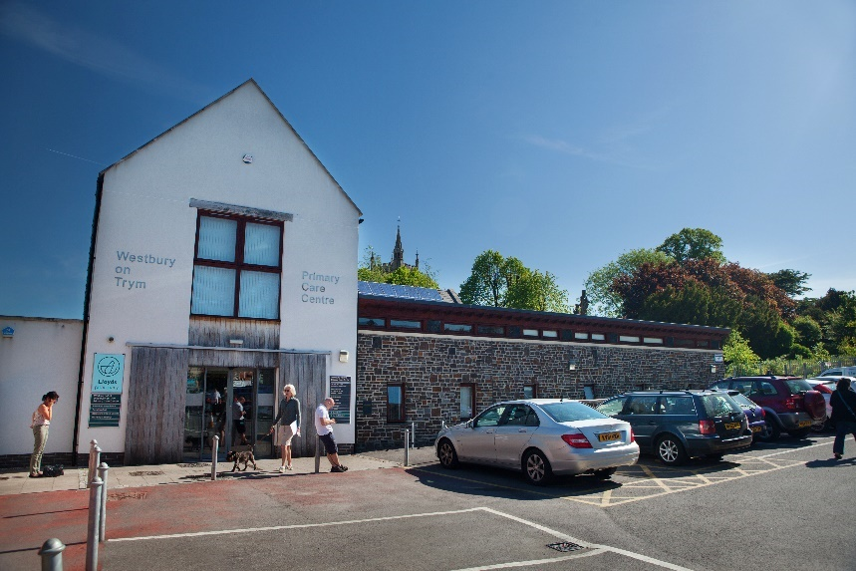

Member of the Affinity PCN


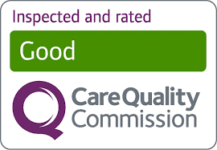

INDEX

Thank you for your interest in this vacancy. The following information provides details of the post as well as a profile of Westbury on Trym Primary Care Centre.

Page 3 Overview & Principal Terms

Page 4 Interview details & Practice profile

Page 5 Advanced Nurse Practitioner Key Responsibilities

Pages 6 Person specification

Overview & Principal Terms

This post provides an opportunity for a suitably qualified candidate with the right clinical skills to undertake the advertised position within a well-run GP medical practice in Bristol.

The suitable candidate will provide medical services to patients presenting with urgent care needs, ensuring the highest standards of care. The role will also include health promotion, family planning, and sexual health. Ideally, the role holder should be able to prescribe.

We will offer an induction programme and a mentor for ongoing support. We are a dynamic and innovative team, always open to new ideas. We are patient-focused and work together to achieve our values. It is possible in this role to develop close, long-term relationships with patients and work in partnership with them to achieve optimum health.

Whilst you are expected to work independently during routine clinics, we are a supportive team and meet daily at coffee to discuss cases and ensure a team ethos is maintained.

We are recruiting for part-time hours 1 – 2 days a week for a fixed term of 6 months starting in September/October 2026. If the opportunity arose to extend this position to a permanent position, we would explore this with the successful candidate. We are looking for an individual who shares our values and if you think this is you, we would welcome an application from you.

You will be entitled to 33 days annual leave (inclusive of Bank Holidays) pro-rata. The post holder will receive an annual salary which will be determined when an offer is made and based on experience.

There is an expectation that all clinicians contribute to any additional NHS contractual hours. At this time, this would be for 30 minutes per week but you could collate these into larger chunks of time if you preferred to make them less frequent. Time off in lieu /shifting usual surgery times would be offered in exchange.

The contract includes membership with the NHS Pension Scheme and reimbursement for any MDU fees.
If you have any questions, please contact Dr Amy Davies (Partner); amy.davies26@nhs.net

Please apply with a covering letter and your CV to Catherine Farrington (Practice Manager); catherine.farrington@nhs.net

The covering letter should be a Word document or a PDF of ideally no more than one page of A4. Please provide details of your relevant experience, knowledge and your skills and how they apply to this job role.

We you the best of luck with your application!

Interview details and selection process

You will be informed by email soon after applications have been reviewed, if you have been invited for an interview.

Interviews dates have not yet been confirmed, but we will be flexible on the date and time wherever possible in order to best support candidates with their applications.

If an offer is made, references will be requested and an enhanced DBS (Disclosure and Barring Service) check completed, health questionnaire, and a receipt of proof of eligibility of employment.

Practice profile

We are a friendly teaching practice providing primary care services in Bristol. We strive to provide an excellent clinical service to our patients with our hardworking team. We are a practice in the centre of Westbury on Trym in a new purpose-built building serving our community.

Westbury On Trym is situated in the heart of Northwest Bristol. This is a beautiful area of the city for families and professionals and there is an above-average elderly population. This gives the practice an interesting mix. It is a lovely place to live and work if you are considering moving to the area.

The premises are owned by the partnership and are modern, purpose-built and inviting to staff and patients alike.

We are a non-dispensing PMS practice, with a strong interest in both teaching and research. We have a low home visit rate. We are a stable and successful business with 5 GP partners, 5 salaried doctors and an excellent team of advanced nurse practitioners, nurses and practice administration staff. You will be supported by our excellent management team.

There is a strong team ethos within the practice, and it is very important to the partners that this is maintained and developed. All clinicians meet for daily coffee between 10:30 – 11:00am and in the summer months we like to use our garden! In addition, we have an annual wellbeing afternoon and arrange regular social events for the team. Continuous training and development are important and encouraged. Further, we hold regular in-house educational sessions and we provide all associate GPs with a clinical mentor to ensure full integration and support.

We are committed to a patient-centred methodology and have an open and friendly approach. This is reflected in our vision and values:

Working together
Open and honest
Targeting sustainability
Patient-centred
Community focused
Compassionate

Vision: Excellent Healthcare Delivered with Compassion

We understand how busy the life of an ANP is, and we do everything we can to offer support. Our team is further supported by our PCN staff. We have clinical pharmacists, a care co-ordinator, mental health practitioner, and a first contact physiotherapist.

Key responsibilities
Please note that the full job description should be read alongside this pack. The below is a summary and not a full list.

Clinical responsibilities:

- Make professional, autonomous decisions in relation to presenting problems including history taking, examination, investigation, diagnosis, treatment and referral where appropriate, whether or not that patient has already been triaged by the practice. To follow up such patients as is necessary.
- To provide the above not only in 15 minutes face to face consultations but also to undertake telephone consultations.
- To manage acute exacerbations of patient’s chronic diseases.
- Contribute to the development of and adhere to protocols and care plans for the management of chronic disease and common medical conditions.
- Provide appropriate preventative healthcare, counselling, education and advice.
- Prescribe and review, as necessary, in adherence to the practice’s prescribing formulary.
- Produce accurate, contemporaneous and complete records of patient consultation, consistent with legislation, policies and procedures and to maintain the utmost confidentiality in relation to such records.
- Support patients to adopt health promotion strategies that promote healthy lifestyles, and apply principles of self-care.
- Utilise and demonstrate sensitive communication styles, to ensure patients are fully informed and consent to treatment
- Work in the context of a multidisciplinary team with a collaborative, supportive and holistic approach, including referral to, and liaison with hospital services or other agencies.

Other responsibilities within the organisation:
- Awareness of and compliance with all relevant practice policies/guidelines, e.g. prescribing, confidentiality, data protection, health and safety
- A commitment to life-long learning and audit to ensure evidence-based best practice
- Contributing to evaluation/audit and clinical standard setting within the organisation
- Contributing to the development of computer-based patient records
- Contributing to the summarising of patient records and coding patient data
- Attending training and events organised by the practice or other agencies, where appropriate.

Person Specification

Essential | Desirable
Qualifications
• Registered Nurse with Nursing and Midwifery Council  • Recognised Nurse Practitioner qualification/relevant nursing/health degree.  • Meets NMC revalidation requirements in accordance with the NMC Revalidation booklet  • Meets the standards for registered ANP working at advanced level  • Minor illness qualification  • Evidence of CPD | • Qualified triage nurse  • ALS and PALS  • Extended/supplementary Nurse Prescriber status.
Experience & Knowledge
• Experience of working in a healthcare setting  • Experience of managing patients with complex needs  • Experienced in clinical examination skills, including listening to chests.  • Experiences in clinical governance issues in primary care, PGDs and associated policies.  • Venepuncture | • Experience of working in a Primary Care environment.  • Experience of both face-to-face and telephone triage.  • Experience of family planning  • Experience of prescribing and undertaking medication reviews
Skills and Ability
• Advanced Clinical leadership skills  • Good communication skills, including providing difficult messages to patients and families.  • Negotiation and conflict management skills  • Effective time management  • Ability to work as a team member and autonomously. | • Experience of EMIS (GP computer system) & Docman.  • Experience in the use of Office and Outlook  • Interest in Research.
Personal Qualities
• Polite and Confident
• Flexible and cooperative
• Motivated
• Compassionate and empathetic in distressing situations
• Ability to work under pressure
• Effectively utilize resources
• Punctual and committed to supporting the team effort.

